**Design Documents for News Stream**

**Group May13-31**

**Group Members: Jamison Bradley, Lance Staley, Charles Litfin**

**Advisor: Srikanta Tirthupura**

**Client: IBM Rochester**

**Client Contact: Paul Bye**

**Executive Summary of the Project**

The goal of this project is to deliver a web-based application, which will allow the user to access different news feeds from a range of news providers. There will be a backend using IBM’s Infosphere Streams which will gather the articles from various sources, categorize these articles, and detect and aggregate duplicate articles. These articles will be stored in a database with the user’s information and will communicate to the webpage the necessary information to be displayed.

**Hardware Specifications**

Our project will have no hardware based component to it, so there will not be hardware specifications for it.

**Interface Specifications**

The User Interface should be clean, clear, concise, and easy to use. On the left side of the browser will be a table called categories which will list the different category of news topics. When a category is selected articles from that category will be display in the news feed (which will be discussed later). The news feed will be in the center of the page and will display the four most recent articles based on the time posted. There will be a next and previous buttons in the news feed to allow the user to see the next four oldest or the next four newest articles. In the upper right corner will be a search bar which will allow the user to search by keywords and then display the relevant articles in the news feed. There will be a login link in the upper left corner which will redirect you to the login page.

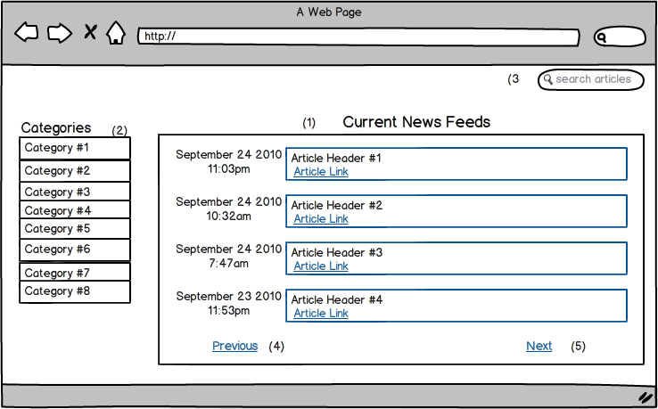

There will be a second page which will be a simple login page. It will ask for your email address and password, and then have both a submit button and a back button. Both of these options will redirect the user to the main homepage after clicking submit or back.

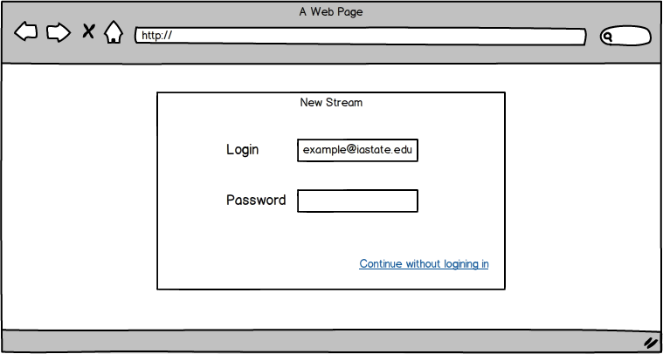

**System Analysis**

Key Word Analyzer:

Our current plan to scan the articles using text analytics written in Java code and the Infosphere Streams to process the input for this function using the build in capabilities of streams and then modify them with our own Java code as needed. The Key Word Analyzer will receive its input from the Data Parsing sub-function.

Data Parsing:

The streams application will pull the text from the articles and allow the parsing of the text from the articles.

Database:

The database will take their input from the processed information from our streams application. It will then store this data in the Database and will sent queries back to the user using JDBC.

Article Aggregation:

The Article Aggregation sub-function will receive its input from the Database. It will then send the information to the user interface to be displayed to the user.

**Use Cases**

* + 1. Article Selection  
       Actor: User

Main Success Story:

a. The user clicks on one of the four article links.  
 b. The article is opened in a new tab and displayed.

Alternate Success Story:

a. The user clicks on the next button in the news feed.

b. The news feeds displays four more articles which are more recent.

c. The user clicks on one of the four article links

d. The article opens in a new tab and the article is displayed.

Alternate Success Story:

a. The user clicks on the previous button in the news feed.

b. The news feeds displays four more articles which are more older.

c. The user clicks on one of the four article links

d. The article opens in a new tab and the article is displayed.

Exception #1 – The article does not display in the new tab.

a. The tab displays a 404 error (page not found error).

2. Category Selection

Actor: User

Main Success Story:

a. The user selects a category link from the list of categories.

b. Articles from the selected category are display in the news feed by most recent articles first.

Exception #1 – No articles fit in the selected category.

a. The news feed displays no articles.

b. A message on the page will say that no results were found.

3. Search for Articles

Actor: User

Main Success Story:

a. The user enters a keyword or words in the search bar.

b. Articles which are relevant to the keyword are displayed in the news feed.

Exception #1 – No articles are relevant to the keywords or words.

a. The news feed display no articles to the user.

b. A message on the page will say that no articles were found.

4. Login

Actor: User

Main Success Story:

a. The user clicks on the login link from the main page.

b. The user is redirected to the login page.

c. The user enters their email and password in the corresponding fields.

d. The user clicks submit.

e. The user successfully logs in and is redirected back to the home page.

Alternate Success Story:

a. The user clicks on the login link from the main page.

b. The user is redirected to the login page.

c. The user clicks the back button and is not logged in and is redirected to the home page.

Exception #1- User email or password is incorrect.

a. The user enters their email and password into the corresponding fields.

b. The user password or email is incorrect and login fails.

c. The user is prompted that their password or email is incorrect and to try again.

**Module Design/System Architecture**

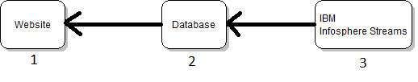

**#1 Website**

This will be our front end that the user will interact with. It will get the stories that are to be displayed and the information about the stories like what category they are in from the database.

**Frontend Modules**  
A. News Display - This will be the module that displays the news stories for the user to view on the website.  
  
B. Options - This module will provide the user with options about what sources are used on the website. The user will be able to select and deselect default sources and add new ones that aren’t part of the default.  
  
C. Login - In order to customize content on the website the user will have to create an account and log in. This module will handle the account creation and login process.

**#2 Database**

The database will store all of the information about the articles that we are displaying on the website. It will be populated with the information from Infosphere Streams.

Tables in Database

Article Table

Article ID - The id that is associated with the article, a unique id will be given to every article. This will be the primary key of the Article Table.

Story ID - The id that is associated with the story the article is talking about, if several articles are about the same story they will have the same id. This will be the primary key in the Story table.

URL- The url of the article.

Source - The name of the news source that the article is from.

Date - The date of publication for the article.

Title - The title that was given to the article by the news source.

Title Keywords - The key words that were found in the title.

Article Keywords - The key words that were found in the article.

Location - The location that the even discussed in the article took place at, can be null.

Category - The category that the news source placed this article in on its website.

Quotations - Quotations that were found in the article.

Story Table

Story ID - See description in Article Table.

Category - The category that the story falls under on our website.

Date - The date that the particular story occurred on, it will be an average of all the articles that match to this story, and will be the date we use on our website.

Title - Will be the title of the story that we display on our website.

**#3 Infosphere**

Our backend will be running on an IBM server with Infosphere streams running on it. The backend will constantly monitor the websites we are supporting and bring in new articles for analysis when they are posted to the websites.

**Backend Modules and Data Flow**

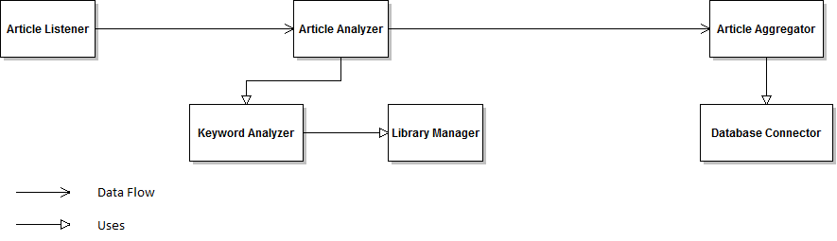

Backend Modules

A. Article Listener - This module will be in charge of finding new articles as they are posted and bringing them into the system for analysis. This will be achieved by having this module constantly monitoring a RSS feed.

B. Article Analyzer - This module will be in charge of determining relevant information about the articles that will be needed for story aggregation.

Information Gathered

#1 The keywords in the title

#2 Date of publication

#3 The keywords in the article

#4 Location (if applicable, not all sites provide this information in the meta data)

#5 Category that the article was placed in on the website it comes from

#6 Quotations from the article if there are any

C. Keyword Analyzer - This module will determine key words in an article. It will achieve this by removing the 1000 most common words in the English language and punctuation from the text. After doing this it will look for words that either don't appear in the dictionary, which would normally indicate that it is a name or something similar, or appear more often than usual.

D. Library Manager - In order for the Keyword Analyzer to do its thing it will need a library of words and information about how often those words appear in normal usage of the English language. Since we are reading in several articles a day it makes sense that we keep updating the library as articles come in so that the sample size continues to grow, making it more accurate. This continuous updating of the library will be the job of this module.

E. Article Aggregator - This module will take the information gathered about the article and try to match it to one of the stories in the database, and if it can't find a story it matches with it will make a new story entry for the article in the database. The matching will be done using a couple of different matching methods and using the results of all of them combined to determine if the article is a match to a given story or not.

D. Database Connector - The Database Connector module will be used by the other modules to both write and read from the database.

**Input Output**

**System**

Input: RSS feed of the websites that we are supporting.

Output: A website containing several different news stories, with articles about the same story aggregated together.

**Infosphere Streams Module**

Input: Link to article from a website that we support.

Output: Entry in the database about what story that article belongs to.

**Infosphere Streams - Article Listener**

Input: RSS feed containing the websites that our system will support.

Output: The source code of the webpage whenever it detects that a new article has been posted on one of the sites.

**Infosphere Streams - Article Analyzer**

Input: Source code of the web page containing a news article from one of the sites that we are supporting.

Output: Several different pieces of information, for more information on what data it will collect look at the module description, that will be useful in determining if the article is about the same story as other articles from different sites.

**Infosphere Streams - Keyword Analyzer**

Input: Text that is written in English.

Output: A list of key words found in that text.

**Infosphere Streams - Library Manager**

Input: Text that is written in English.

Output: The library file will be updated to reflect the occurrences of the words included in the text.

**Infosphere Streams - Article Aggregator**

Input: Information about the article that is obtained by the Article Analyzer module.

Output: The story from that database that the current article being analyzed matches with, or a null output if there isn't a story in the database that it matches to.

**Infosphere Streams - Database Connector**

Input: Data that needs to be stored in the database, or commands to retrieve information from the database.

Output: Confirmation that the data was successfully stored in the database if storing, and the information requested if a retrieval of information was requested.

**Database Module**

Input: Data is sent to be stored or data is requested to be retrieved.

Output: Data is input is stored or data requested is returned.

**Website Module**

Input: Articles from the database are retrieved by the website.

Output: A user interface for the user to interact with and explore the articles we are presenting.

**Functional Decomposition and Test Plan**

**Overall Function:** The overall function of our project is to take in news articles from several different news sites and then aggregate that data together on one website.

**Infosphere Streams - Article Listener**

RSS Feed Monitoring: This function will monitor an RSS feed to determine whenever a news site that we are supporting has posted a new article. Whenever it detects that a new article has been published it will get the source code of the page that the article is published on.

Test Plan Procedure: After we get this written will look at the RSS feed to see what articles are on it and then we will make sure that this function is detected all of them and gathering the source code.

Test Plan Interpretation: If the function is gathering information from all of the links on the RSS feed it will be considered a successful test.

**Infosphere Streams - Keyword Analyzer**

Removal of Common Words: This function will remove the 1000 most common words in the English language from a string of text. The words being removed should never be considered a key word since they are so commonly used in English. The function will return a list of words in the article that aren't common.

Test Plan Procedure: This function will be tested by unit tests. A couple of articles will be tested and if any of the words the function returns are on the list of common words it will have failed the test.

Test Plan Interpretation: If the unit test are successful we will be able to feel confident that common words are being removed correctly.

Key Word Detection: This function will take a list of non common words and determine which ones in the list are likely key words.

Test Plan Procedure: We will unit test this function by inputting list of words that we have designed, and already know what key words should be detected.

Test Plan Interpretation: If the function is picking out the correct words that we believe our algorithm should pick out we will consider the test to be successful.

**Infosphere Streams - Article Analyzer**

Parser: This function will parse the source code of web sites that our project is pulling articles from to get the desired information like the text of the article. Each website will have a slightly different format so this function will rely on plug-ins to know how to parse the different website's source code.

Test Plan Procedure: We will make test case for each site we are going to support, were we pick out the information it should gather by hand and use unit tests to make sure it picks out the same data.

Test Plan Interpretation: If the function is correctly picking out the data for our test cases we will consider the test a success.

**Infosphere Streams - Article Aggregator**

Match Story: This function will look at the stories that are already stored in the database and see if any of them are the same as the story that is currently being analyzed by the Infosphere Streams module. If the article is similar it will return information about the story it is similar too, if it isn't similar it will return that the article is a new story.

Test Plan Procedure: This will be more of an art than a science, since our algorithm will likely not be capable of working for every single story. So we will look at how stories are getting grouped and continue to tweak the algorithm to make it the best we can.

Test Plan Interpretation: If the majority of the articles are getting grouped correctly, and we feel we can't improve the algorithm any more we will consider the function to be complete.

**Infosphere Streams - Database Connector**

Retrieve Information: This function will retrieve information from the database to be used by other functions in the Infosphere Streams module.

Test Plan Procedure: We will write a series of unit tests to retrieve information from the database, and test to make sure the correct things were retrieved.

Test Plan Interpretation: If the unit tests all pass we will feel confident that the function is working correctly.

Store Information: This function will store information in the database.

Test Plan Procedure: We will combine the testing of this function with the Retrieve Information function. We will create some unit tests were we store some information then immediately retrieve it.

Test Plan Interpretation: If the unit tests that we include this function in are all passing we will consider the test to be a success.

**Sources**

#1 CNN (US)

#2 New York Times (US)

#3 Des Moines Register (US/Iowa)

#4 The Guardian (UK)

#5 BBC (UK)

#6 Toronto Sun (Canada)

#7 The Australian (Australia)

#8 Al Jazeera English (Qatar)

#9 New Zealand Herald (New Zealand)

#10 The Local (Sweden)

**Project Measures**

Our goal is to create a program to categorize and aggregate news articles using IBM Infosphere streams software. The table below shows our metrics.

|  |  |  |
| --- | --- | --- |
| Goal | Question(s) | Metric(s) |
| Producing our software in a reasonable amount of time. | How long will it take to produce? | Until three weeks before the end of CprE 492 |
| Producing a product with a long sustainability. | How long is a long sustainability? | As long as the product is still useful and/or profitable to IBM |
|  | The cost to sustain the product? | The cost of any additional programming needed to fix discovered bugs |
| Have reasonable accuracy in article aggregation and category grouping | What is a reasonable aggregation accuracy | 80% of all articles or more should be correctly aggregated. |
|  | What is a reasonable category grouping accuracy? | It will also be 80% |
| Have a reasonable response time between article creation and addition to the database | What is a reasonable response time? | One hour |

**Functional Requirements**

**A). Infosphere Backend**

**1. Obtaining Articles**

The backend should be able to pull articles off of the internet and add them to the database. The backend will obtain whole article contents plus links back to the original source.

**2. Scanning**

The backend should be continuously scanning the preselected sources for new articles to be added to the database. It should have a turnaround time of less than a hour.

**3. Sorting**

The backend should be able to sort articles into a number of categories based on the category the articles are designated into on their source website. These categories will include such topics as sports and politics.

**B). Database**

**1.) Article Information**

Each article should be stored with the information that is specified by the Article Table in the database.

**2.) Categories**

Each category has multiple articles assigned to it, but each article can belong to no more than one category.

**3.) Aggregation**

The database should be able to correctly identify which articles are duplicates and which are unique. The duplicate ones will be marked as such and grouped with other articles containing identical content.

**C.) User Interface**

**1. User Access**

The user should be able to use a pre-existing Facebook profile to login. This will help lower the amount of content that must be saved per account and avoid opening new security risks that a new login system would create.

**2. Article Access**

The user will be able to access articles through links listed under a number of fixed categories. These articles will be presented as the article title in text along with a link back to the original web source of the article.

**3. Customization**

The user will be able to remove sources that our supported that the user does not want to see articles from. Also the user should be allowed to add any previously removed sources. If additional time is available at the end of development there will be plans to allow the user to add their own sources.

**Non-Functional Requirements**

**1). Security**

**A).Username**

A user account is associated with a single username and password, as well any modifications the user has made to their sources.

**2). Performance Requirements**

**A). Speed**

The system should be able to obtain a news article quickly after the article is posted to an RSS feed. The current requirement will be adding an article within one hour of the article being added to an RSS feed.

**B.) Interface**

The user interface should respond quickly to user input in order to facilitate faster use overall. The user interface should also be user friendly in order to make news consumption easier.

**Risks and Mitigations**

|  |  |  |  |  |
| --- | --- | --- | --- | --- |
| *Risk* | *Probability of Occurrence* | *Criticality (0-100)* | *Risk Factor (Prob. Of Occurrence x Criticality)* | *Mitigation strategy* |
| The IBM Streams software has not been used by any of our members and could be difficult to learn and implement | .50 | 80 | 40 | Hold a meeting with our IBM contact about streams as well as prototyping small streams applications for experience |
| Lack of experience with web development | .40 | 60 | 24 | Research web development as well as prototype some web development |
| Development of the article comparison algorithm is more difficult than expected | .30 | 75 | 22.5 | Research to see if there are any third party algorithms that could be used. Build a prototype of the algorithm to test early on. Add extra time to the schedule. |
| Usability in many different web browsers and operating systems | .40 | 50 | 20 | Research and develop for a number of browsers |
| We are unable to get streams to work with our java back and web frontend. | .20 | 50 | 10 | Research alternate design options as well as using streams with external code |

**Standards**

Our team shall always follow the same coding guidelines throughout the project. At the start of every Java, HTML, CSS, or other file should be a comment describing what the file is for and does. All functions will have comments one line above the function declaration declaring what the function does and how the function works. There shall be two blank lines between the end of one function and the start of another function. The “{“ after a function will be on the same line as the function with one space between the function and the bracket. The closing bracket should line up with the starting position of the declaration with the corresponding opening bracket. All if, for, and while loop statements should be indented one tab from where function declaration starts. All other code embedded inside a loop should be indented one tab from the loop declaration starting position. There should be one space on each side of any operators ( =,-,+ ,*, etc.). An example is: x = y + 5. All testing should be documented on what was done and the corresponding results of the tests.